Writing Code for Other People  Tom Mullen  Expert behaviour  Short term memory  Long term memory  Analogies  Chunk  Laws of Prägnanz  Object oriented design  Open-closed  Structured design  Refactoring  Design patterns  Coupling/cohesion  Cognitive Psychology Software Design  Current software languages and design principles guide a programmer to produce code that is a direct textual representation of the memory network of the solution within the brain (subject to the constraints of short term memory).  Conjecture  The core fundamental metric of software design is that software should be chunked in elements of four (or fewer) after allowing for any number of varieties of analogies.  Four minus Analogies Rule  tom@tom-mullen.com  Presentation Materials:  http://www.chunkinganalogies.com  Software design is mostly a task of chunking analogies |  | Writing Code for Other People  Tom Mullen  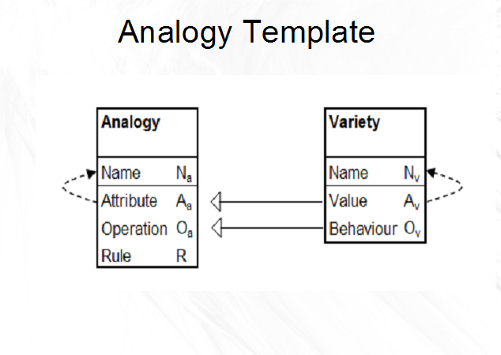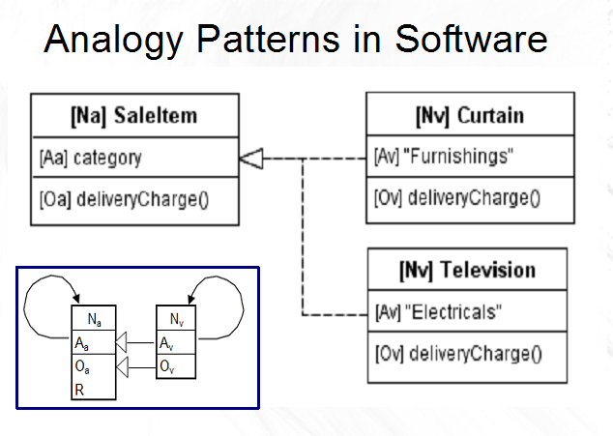  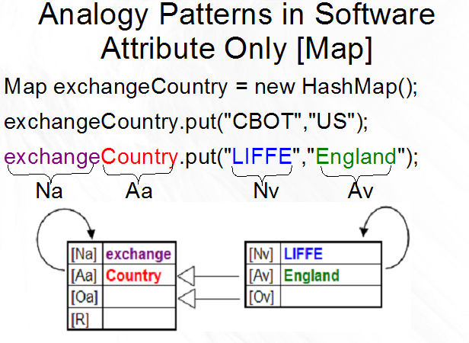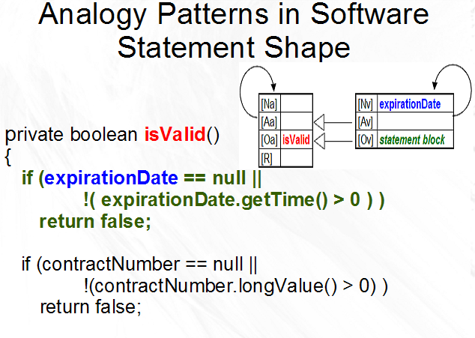  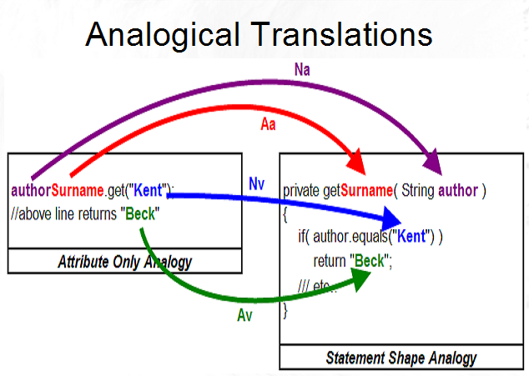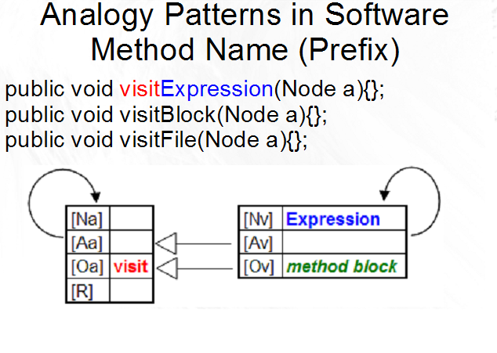  tom@tom-mullen.com  Presentation Materials:  http://www.chunkinganalogies.com

